“ Fueled by coffee –

Slow Bar ”

BCSC 3B

Paul Cedric G. Cruto

Brainier Andrew H. Manalo

Zhan Kimberly G. Escasinas

INTRODUCTION:

"Fueled by Coffee" Pop-Up brings the vibrant energy of your favorite coffee shop to unique locations, transforming everyday spaces into a caffeinated haven. Designed for coffee enthusiasts on the go, this pop-up experience combines expertly brewed coffee, and a warm inviting vibe wherever it sets up. Be it a busy corner, a corporate event, or a vibrant marketplace, "Fueled by Coffee" delivers the same high-quality drinks you love no matter the location. With its sleek setup, and the styling friendliness of our baristas, the pop-up isn't about coffee nearly as much as it is about creating spaces for people to inhabit in order to make connections and have conversations. Each time you step up to the counter, it’s a near guarantee that you’re not just getting a drink—you’re getting a moment.

Ideal for individuals who long for exceptional coffee but can't stop to savor it, "Fueled by Coffee" Pop-Up offers accessible, high-quality coffee that you can enjoy while you're living your life. It makes that most perfect of coffee-drinking experiences—indeed, the most perfect of drinking-anything experiences—one that brings people together, one cup at a time. "Fueled by Coffee" Pop-Up was established in July 2024 and is driven by a love for extraordinary coffee. We desire to craft not only good coffee but also good coffee experiences—ones that are accessible, unique, and memorable.

“HOME PAGE AND LOGIN AND LOG OUT SCREEN OF FUELED BY COFFEE” The web interface presented here is for a Point-of-Sale (POS) system dubbed "Fueled By Coffee." It seems purpose-built to manage not just the sales aspect but also the overall operational side of a coffee shop. Below is a hefty explanation of what the interface offers and some basic insights into how to use it.

The title "Fueled By Coffee" serves as the application or brand name. The options in the navigation menu are displayed (Home, Coffee, and Non-Coffee). These probably link to various parts of the app, like a menu for coffee or something for non-coffee drinks. At the top right corner, there is a Logout button, which lets the user end their session securely. Welcome Section: The application extends a greeting to the user (e.g., "Welcome, cedric!"), implying a tailored experience. This signals that the user has gained entry to their account.

Welcome Section:

The application greets the user (e.g. “Welcome, cedric!”, making it feel more tailored to you. This means that the user has successfully logged into his account.

Purpose Statement:

Under the welcome text is a message saying, "Enjoy your experience at Fueled By Coffee, visit our menu," inviting users to visit the website.

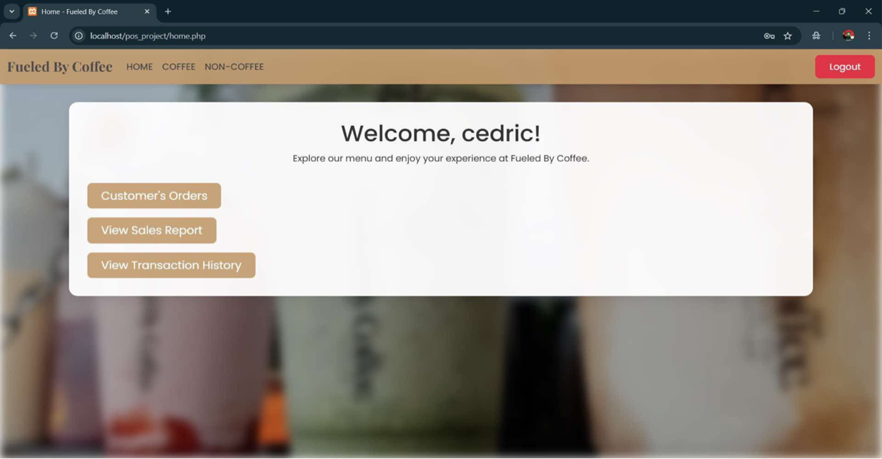

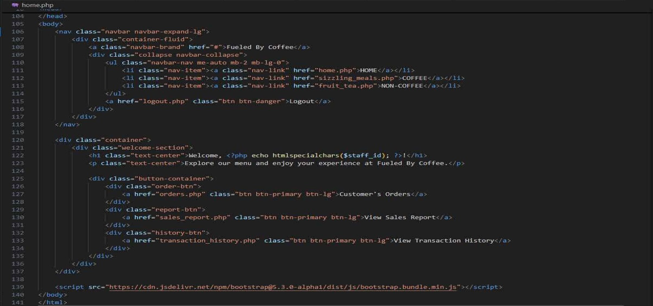

Here’s the code for home page ,

you need to set the content of the document title to a string, in this case our title will be "Login - Powered By Coffee" which will display in the frontend in a browser tab

Logo and Branding:

The logo or branding text for "Fueled By Coffee" is visible in the background

Login Form:

This top section contains 2 input fields for Username and Password.

Button for users to log in.

Click here to register:

For users without account, likely linking to a registration page.

The URL indicates that this is from a project that is hosted locally on the project “pos_project,” probably on a local project development server (localhost). Here, login is the specific file being accessed..php — suggesting perhaps a PHP web application. This setup is generally employed for testing or development before pushing the project to a live server.

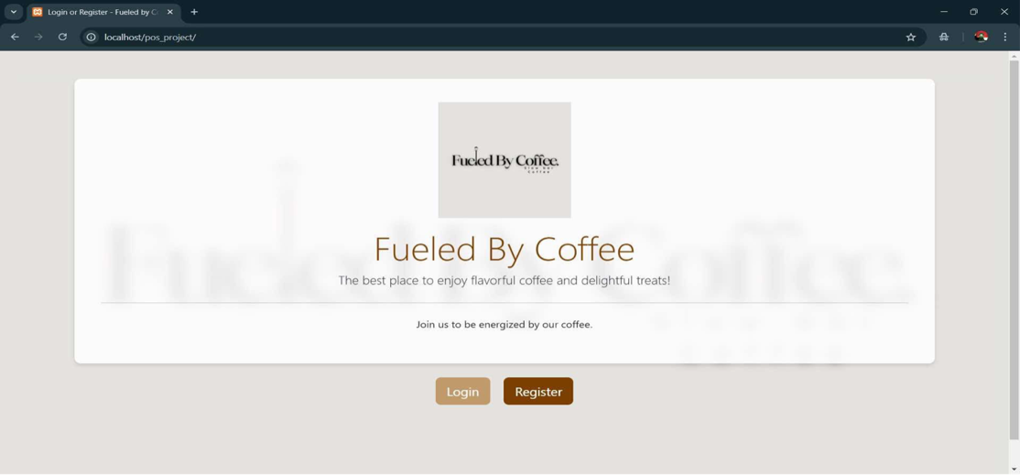

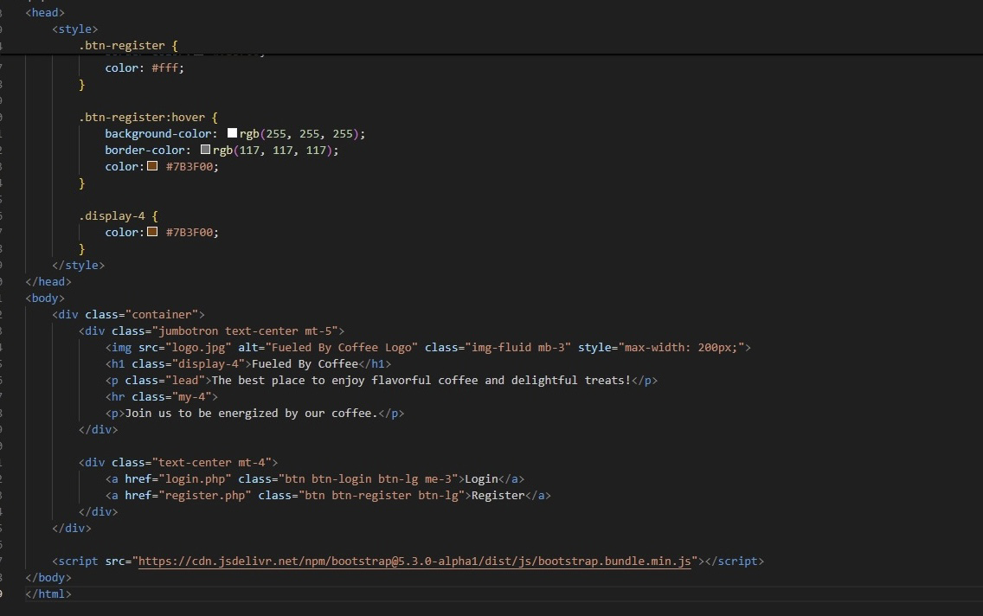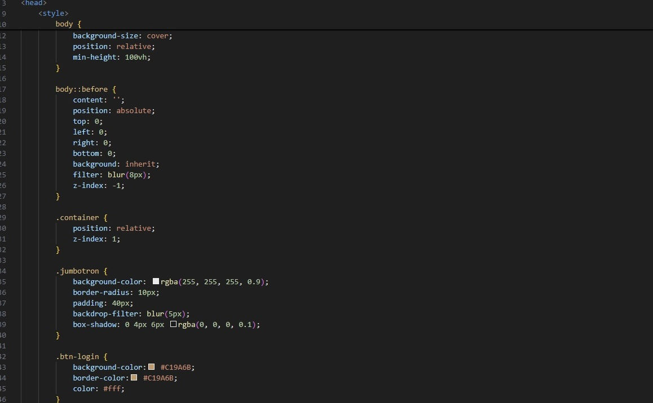

Here’s the code for index,

The register is for new users who want to easily order and get drinks for customers.

This procedure will display all the necessary details required to gain access to the system and to order the two or three drinks or treats that the customer wants.

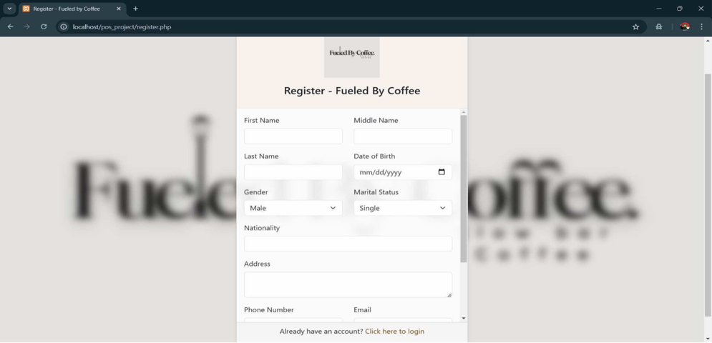

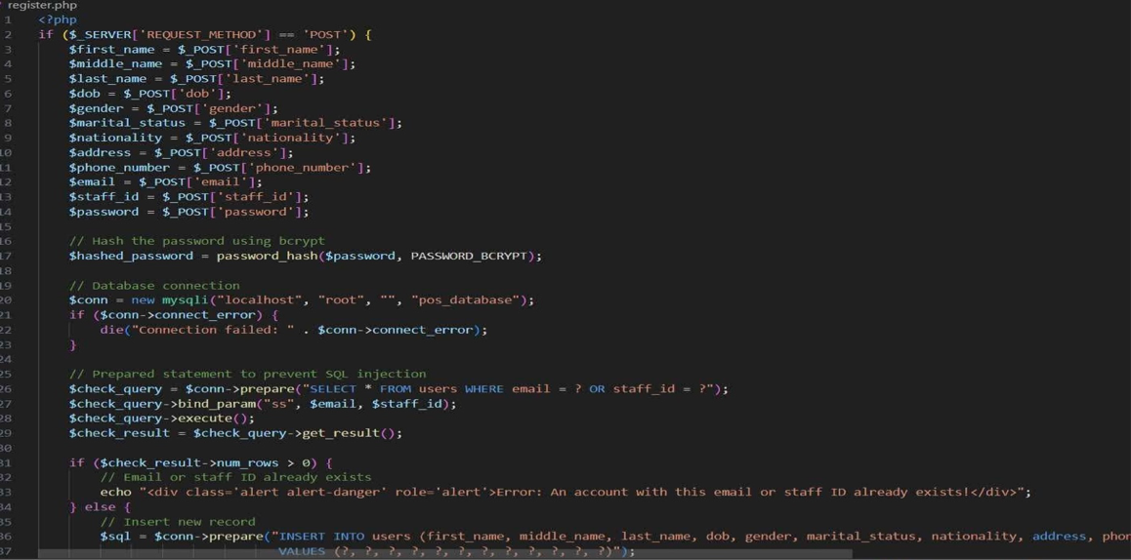

Here’s the code for registration,

This interface is a strikingly advanced web application, most probably designed for the thorough management of a point-of-sale (POS) system including coffee products along with non-coffee items.

The navigation menu provides at least three options, namely "HOME," "COFFEE," in addition to "NON-COFFEE," enabling users to move between the different website sections.

This form allows for the addition or updating of a certain number of coffee entries.

The input form requires at least one coffee name, a regular price, a large serving price and a numerical stock quantity.

Two important buttons are available:

Add Coffee, which allows users to add a completely new coffee item to the system and Update Coffee, which enables modification of the details for an existing coffee item.

The Products table prominently features columns for Product ID, Non-Coffee Name, Regular Price, Large Price, Stock quantity, as well as Actions that allow for editing or deleting items.

The Spanish Latte, a non-coffee product, has a regular price of ₱75.00 for a small serving and a price of ₱100.00 for a large serving. Approximately thirty units of this product are currently in stock.

This interface enables users to manage at least some inventory, to add or edit a minimum of three products, as well as to adjust at least two prices within a coffee-related business.

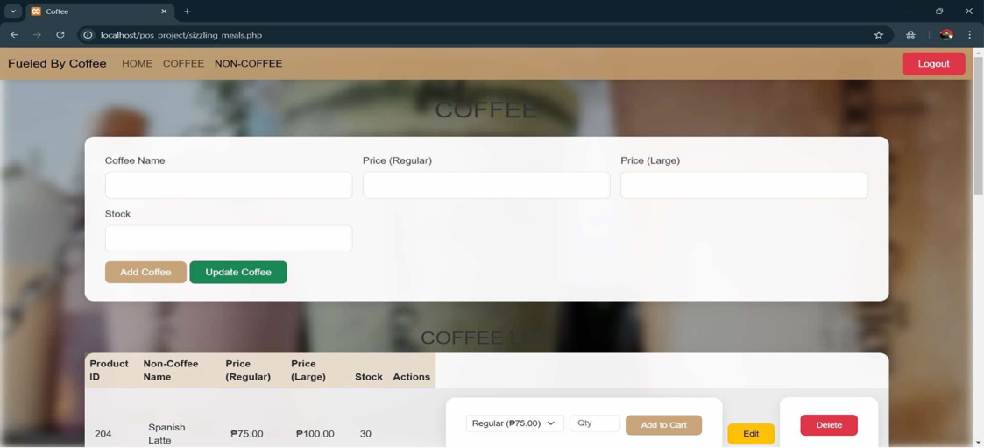

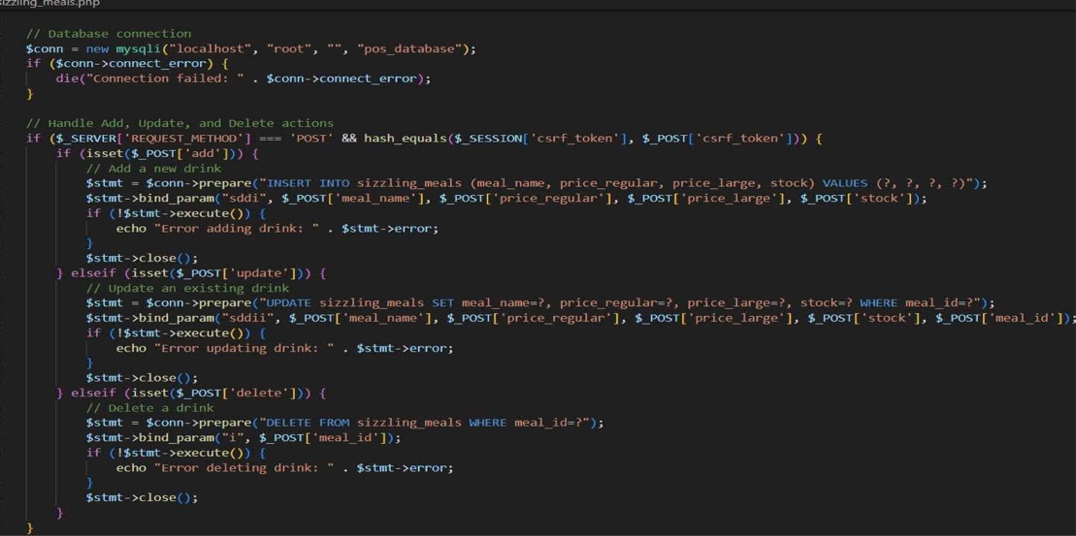

Here’s the code for coffee,

This screen is part of a web application designed for managing products in a point-of-sale system. Here’s a detailed overview of the page:

Navigation Menu: Features sections for "HOME," "COFFEE," and "NON-COFFEE."

Main Section:

Form for Adding or Updating Non-Coffee Products:

Input fields:

Non-Coffee Name: For entering the name of the non-coffee product.

Price (Regular): To specify the price for the regular size.

Price (Large): To indicate the price for the large size.

Stock: For inputting the available quantity in stock.

Buttons:

Add NON-Coffee: To add a new non-coffee product to the inventory.

Update NON-Coffee: To modify the details of an existing non-coffee product.

Non-Coffee Product List:

Columns:

Product ID: A unique identifier assigned to each product.

Non-Coffee Name: The name of the product.

Price (Regular): The price for the regular size.

Price (Large): The price for the large size.

Stock: The current available quantity.

Actions: Buttons for editing or deleting the product.

Example Product:

Product ID: 102

Non-Coffee Name: "Matcha"

Price (Regular): ₱80.00

Price (Large): ₱105.00

Stock: 20 units

Action Buttons:

Edit: Opens the interface for editing product details.

Delete: Removes the product from the inventory.

Purpose:

This page is dedicated to managing non-coffee items in the inventory, including teas, juices, and other beverages. It offers a straightforward way for users to add, edit, or delete non-coffee products and update stock or pricing information.

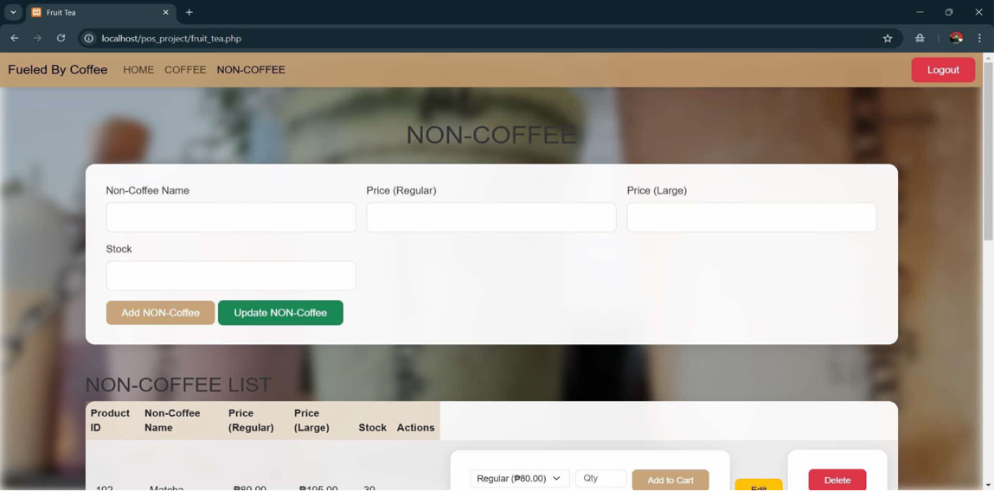

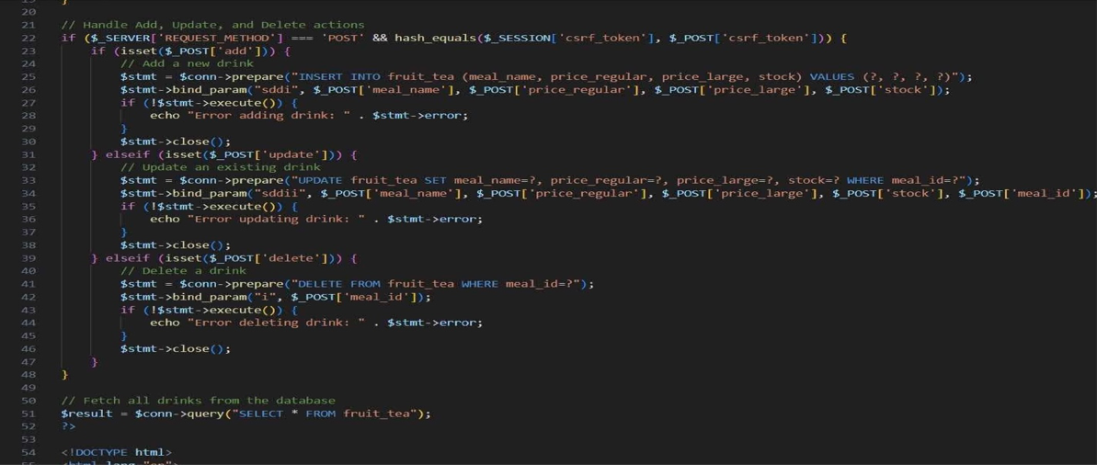

Here’s the code for Non-coffee,

This image is a screenshot of a point-of-sale (POS) web application called "Fueled By Coffee." It displays the "All Orders" page, which shows the current orders made by customers. Here’s a breakdown of the components visible in the interface:

Orders Table:

Columns include:

Product ID: The unique identifier for each product.

Meal Name or Drink Name: The name of the item being ordered.

Quantity: The number of items ordered.

Price (₱): The cost of a single unit.

Total Price (₱): The total cost for that item based on the quantity ordered.

Transaction Date: The date when the order was placed.

Action: Likely a button to modify or remove the order.

Currently, the table shows "No orders found," indicating that no orders have been placed yet.

Discount Section:

There’s a text input for entering a Discount Code and a button labeled "Apply Discount."

Price Summary:

Displays the Total Price, which is currently ₱0.00, as there are no items in the order list.

Action Button:

A "Process Payment" button is available to complete the transaction once items are added.

This interface is designed for managing orders in a coffee shop, with features for applying discounts and finalizing payments.

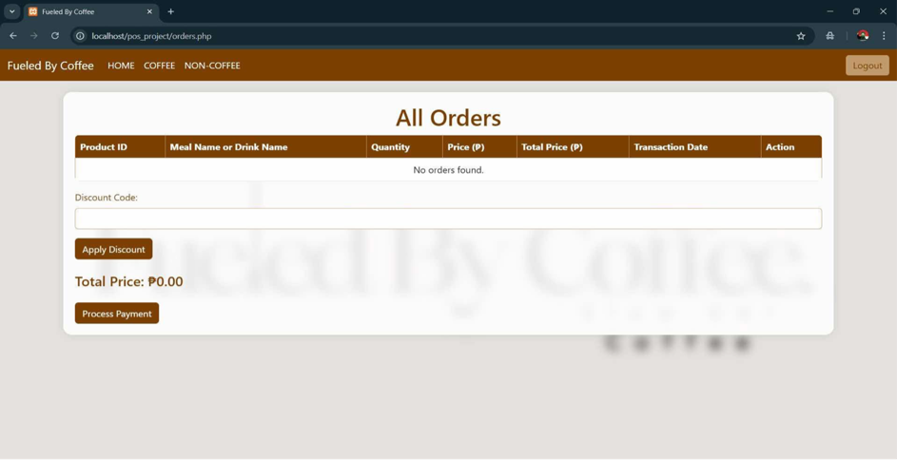

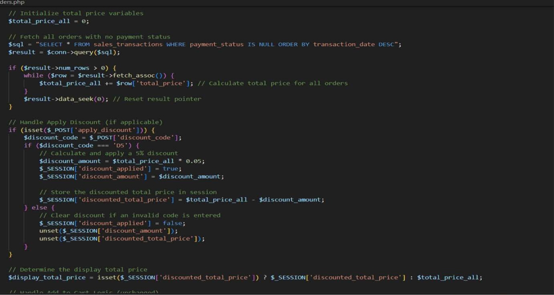

Here’s the code for all orders,

This screenshot shows the Sales Report page of the "Fueled by Coffee" point-of-sale (POS) web application. The page provides a summary of sales performance across various time periods. Here’s a closer look at the layout:

Navigation: A "Back to Home" button enables users to return to the main menu.

Sales Overview

Four summary cards offer a quick glance at sales:

Today's Sales: ₱741.25

This Week's Sales: ₱741.25

This Month's Sales: ₱741.25

This Year's Sales: ₱741.25

The identical values suggest that there has only been one transaction or sales activity today, which is reflected across all periods.

Sales Summary (Detailed) Table

Beneath the cards is a detailed sales breakdown, displaying:

Period: Categories like "Today," "This Week," "This Month," and "This Year."

Total Sales (₱): The total sales figure for each period, which is ₱741.25 for all entries.

This page presents a clear view of sales performance, making it straightforward to track and analyze revenue over different time frames.

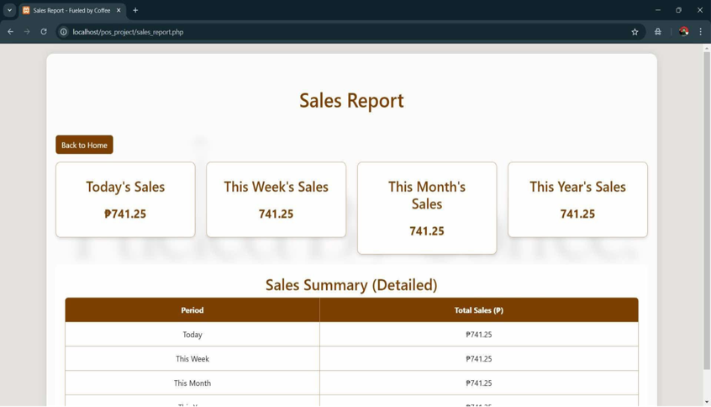

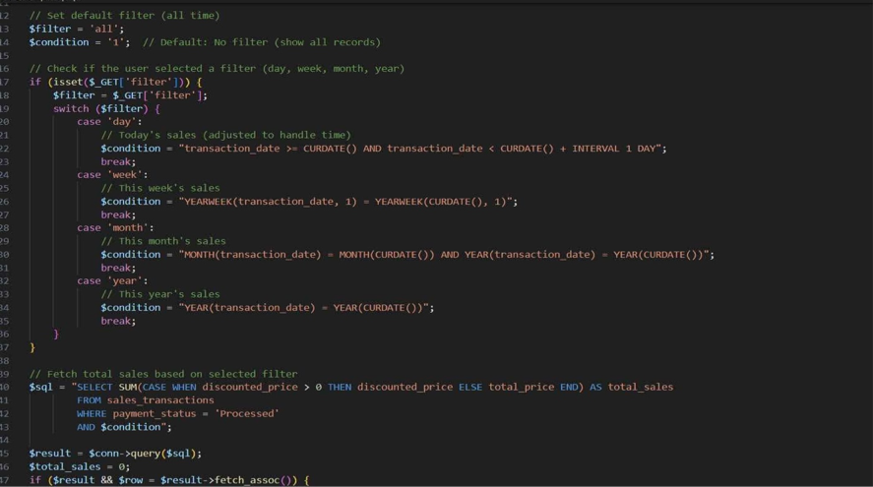

Here’s the code for sales report,

This screenshot displays the Transaction History page of the "Fueled by Coffee" point-of-sale (POS) system. The main function of this page is to showcase all recorded transactions along with their relevant details. Here’s a closer look.

Transaction History Table

The table provides comprehensive information about recent transactions, organized into columns:

Transaction ID: A unique identifier assigned to each transaction (e.g., 23, 22, etc.).

Meal ID: The unique identifier for the meal or drink ordered (e.g., 204, 103, etc.).

Meal Name: The name of the ordered item (e.g., Spanish Latte, Strawberry Matcha, etc.).

Quantity: The number of items ordered in the transaction.

Price: The cost per unit of the item.

Total Price: The overall cost for the quantity of items ordered.

Transaction Date: The date and time when the transaction occurred (e.g., 2025-01-14 06:45:41).

Payment Status: The status of the payment, which is "Processed" for all transactions listed.

Batch ID: A unique identifier for the batch or group of transactions processed together.

Observations

The table features five transactions, showcasing a variety of items such as Spanish Latte, Strawberry Matcha, and Caramel Latte.

Most transactions are categorized under the same Batch ID (1736832292), suggesting they were processed in close succession.

The Total Price values align well with the Quantity and Price columns.

This page offers a straightforward and organized record of past transactions, allowing users to effectively monitor and track sales activities.

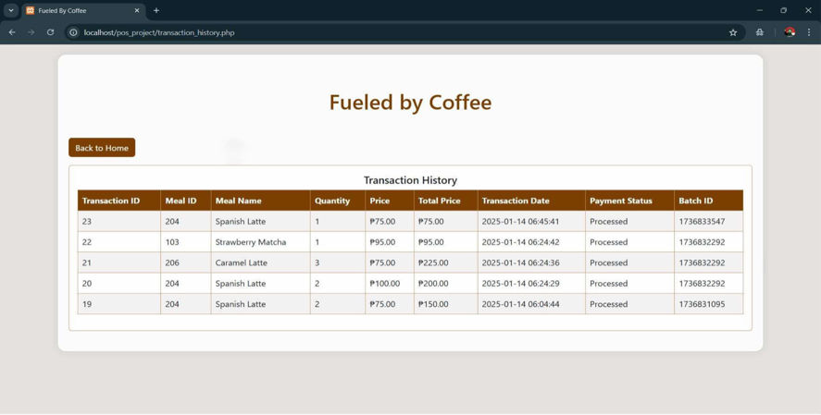

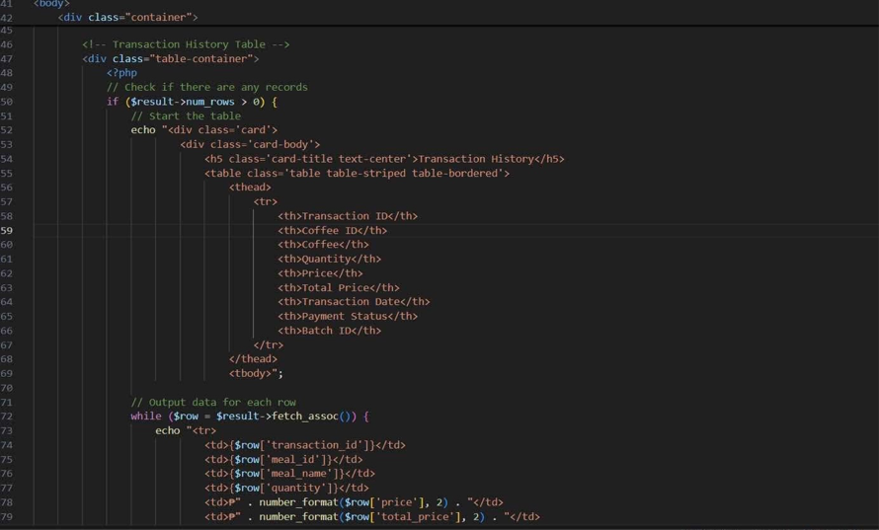

here’s the code for transaction history,

This is a screenshot of a webpage that shows receipts from a point-of-sale (POS) system named "Fueled By Coffee." The receipts provide a summary of customer transactions, detailing aspects like the meal name, quantity, price, and total amount. Here’s a breakdown of the content:

Receipts Displayed:

Receipt #1

Transaction Date and Time: 2025-01-14 06:04:44

Item Details:

Meal Name: Spanish Latte

Quantity: 2

Price (₱): 75.00

Total (₱): 150.00

Summary:

Total Price: ₱150.00

Discount Applied: ₱0.00

Receipt #2

Transaction Date and Time: 2025-01-14 06:24:42

Item Details:

Spanish Latte:

Quantity: 2

Price (₱): 100.00

Total (₱): 200.00

Caramel Latte:

Quantity: 3

Price (₱): 75.00

Total (₱): 225.00

Strawberry Matcha:

Quantity: 1

Price (₱): 95.00

Total (₱): 95.00

Summary:

Total Price: ₱520.00

Discount Applied: ₱0.00

Purpose

This page likely serves as part of a POS system where:

Users (like cashiers or managers) can look over previous transactions.

Order details are recorded and displayed for record-keeping, audits, or reporting purposes.

The use of Philippine pesos (₱) indicates that this system is designed for businesses operating in the Philippines.

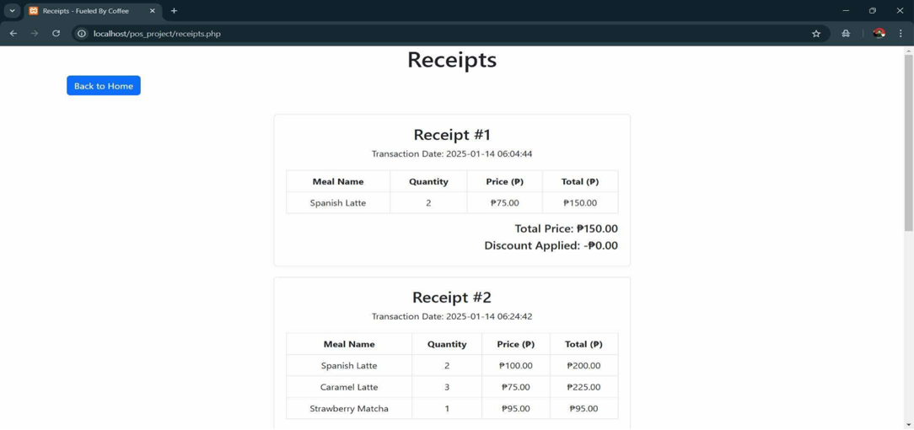

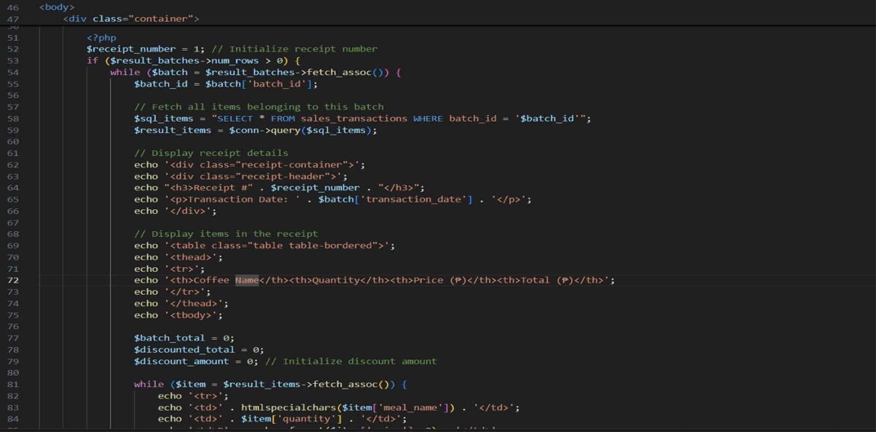

here’s the code for receipt